Remember Me Softly

Memory Bears and Pillow

Order Form

Please print this form, fill out the information, and mail the form and payment with the article of clothing of your choosing to:
4126 Shannon Drive, Hastings, MN 55033
*Please call with any questions: 651-491-1404
*Please address checks to Melanee Theodorson

Name:
Phone Number:
Return Address:

Do you want bear(s) ($40 each)?
If yes, how many?

Do you want pillow(s) ($20 each)?
If yes, how many?

Which font for the patch?
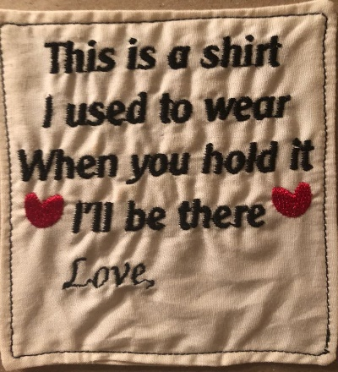

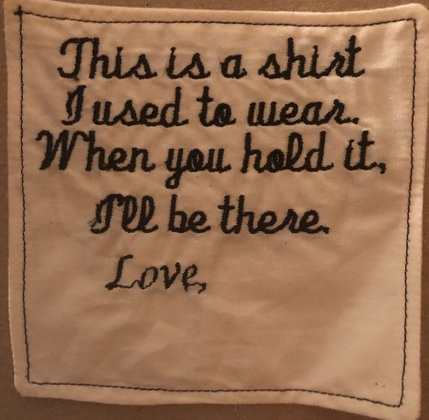
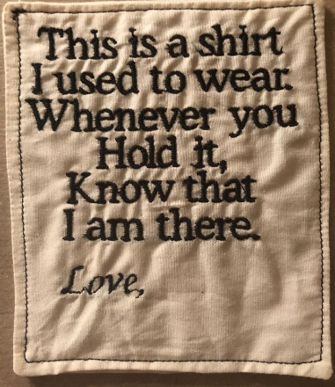

I would like the patches addressed Love, __________________________________
If you would like the wording different on the patch please contact me.

*please fill out other page.

Bears ($40/each) X ________________
Pillows ($20/each) X ________________

Pick up option available in Hastings MN. or add the following shipping rates to your total payment:
Return Shipping 1-2 items ($20)
3-4 items ($35)
5-6 items ($55)
7-8 items ($70)

If you would like the remnants returned please add 10.00 to shipping

Total: __________

Additional Comments:

I will contact you as soon as your items arrive and let you know how long your order will take to complete

